**A PROJECT REPORT ON**

**“Electronic Thesis and Dissertation”**

FOR

**GMIT**

SUBMITTED IN PARTIAL

FULFILLMENT OF INTERNSHIP PROJECT

UNDER THE GUIDEDANCE OF

Director

**Mr. Ravi Chhabra**

Supervisor

**Dr. Ei Ei Mon**

**SUBMITTED BY**

Ma Ei Po Po Aung

Ma Apirl Su

Ma Myo Myo

Ma Htet Htet Htun

Ma Su Sandi Myint Naing

Ma Shun Lae Nadi Moe

**University of Computer Studies (Mandalay)**

27.8.2018

**Group** **Members**

|  |  |  |  |
| --- | --- | --- | --- |
| **Roll No** | **Name** | **Signature** | **Date** |
| 5CS – 13 | Ma Ei Po Po Aung |  |  |
| 5CS – 14 | Ma Apirl Su |  |  |
| 5CS – 15 | Ma Myo Myo |  |  |
| 5CS – 16 | Ma Htet Htet Htun |  |  |
| 5CS – 17 | Ma Su Sandi Myint Naing |  |  |
| 5CS - 18 | Ma Shun Lae Nadi Moe |  |  |

Dr. Ei Ei Mon Signature/Date

**CONTENTS**

**Page Number**

**Abstract** i

**Acknowledgement** ii

**Declaration** iii

**List of figures** iv

**CHAPTER 1 INTRODUCTION 1**

1.1 Introduction 1

1.2 Background 2

1.2.1 What is a firebase hosting 2

1.2.5 What is a firebase database? 3

1.3 Objective of the project 5

1.4 Scope of Proposed System 5

**CHAPTER 2**  **METHDOLOGY 6**

2.1 Requirement Analysis 6

2.2 Software Selection 6

2.3 Project Plan 7

**CHAPTER 3 PROJECT DEVELOPMENT 8**

3.1 Design 8

3.1.1 Flow Chart Diagram 8

3.1.2 Use Case Diagram 11

3.1.3 Sequence Diagram 12

3.1.4 ETD Function 13

3.2 Implementation **23**

3.2.1 Database Implementation 23

3.3 Testing **24**

3.3.1 Integration Testing 24

**CHAPTER 4 EVALUATION AND CONCLUSION 28**

4.1 Conclusion 28

4.2 Advantages of the project 29

4.3 Disadvantages of the project 29

4.4 Further Extensions 29

**References 30**

**Abstract**

Electronic Thesis and Dissertation System is a work submitted in support of candidature for a doctorate or master’s degree. Electronic version of theses and dissertations are called ETDs. This system is kind of Education website. In our system , users can search theses and dissertations of CU (Mdy) by Year, and can see abstract of the thesis, author name, supervisor name and the major. Users can also search books and theses of Otago University and Global ETD for more references.

For admin Panel, admins can insert, data into database, delete and retrieve data for database. Users can use our system with both smart phones and computers. For Front End, the system was implemented using material design (HTML, CSS).For Back End, this system was implemented using javascript and jQuery. And we also used Firebase Hosting and Database.

**i**

**ACKNOWLEDGEMENT**

We would like to express our very great appreciation to **U Kyaw Zwa Soe**, Rector, Computer University (Mandalay).

We would like to respectfully thank our pro-rector **Dr. San San Tin**, her kind permission to develop this project.

We would deeply thankful to our teacher **Dr. Aye Aye Chaw** for her valuable and constructive suggestion during the planning and development of this project. They willingness to give their time so generously has been very much appreciated. Advice given by other academic lectures has been a great help in building the software solution.

Then also thanks to **U Ravi Chhabra**, CEO of GMIT, for his trust to give us such a heavy responsibility project.

And Then greatly thankful to my supervisor **Dr. Ei Ei Mon**, Computer University (Mandalay), for her valuable guidance and patient supervisor, presentation and correctness of the project.

We especially thanks to our parents and all our friends for providing encouragement and giving us a great support during internship programme.

**ii**

**DECLARATION**

We declare that this project report or part of was not a copy of a document done by any organization, university any other institute or a previous student project group at Computer University (Mandalay) and was not copied from the Internet or other sources.

Project Details

|  |  |
| --- | --- |
| Project Title | Electronic Thesis and Dissertation System |
| Project ID | GMIT Company Internship |

**iii**

**List of Figures**

**Figure Page**

Figure (2.1) Project Plan 7

Figure (3.1) Flowchart Diagram For Admin 8

Figure (3.2) Flowchart Diagram For User 9

Figure (3.3) UseCase Diagram For ETD 10

Figure (3.4) Sequence Diagram For ETD 11

Figure (3.5) Navigation Bar Form 12

Figure (3.6) Home Page Form 13

Figure (3.7) Thesis Resource Form 14

Figure (3.8) Thesis Resource Form By Year And Title 15

Figure (3.9) Thesis Resource With Details 16

Figure (3.10) Publisher Form 17

Figure (3.11) Information Of The Title That User Click 18

Figure (3.12) Admin Form 19

Figure (3.13) Admin login Form With Email 20

Figure (3.14) Detail Information By Year For Admin 20

Figure (3.15) Learn More Form 20

Figure (3.16) Global ETD Form 21

Figure (3.17) Data Of Project 22

Figure (3.18)Data Of Each Year Under Project 23

Figure (3.19)Data Of Id Under Project 24

**iv**

Figure (3.20)

Figure (3.21) Allow Login And Check Permission25

Figure (3.22) Permit Authorization Person 26

Figure (3.23) Allow Login And Check Permission 27

Figure (3.24) Permission Deny When Not Given Authorization 27

**v**

**Chapter 1**

**Introduction**

* 1. **Introduction**

**1**

**1.2 Background of the System**

**1.2.1 What is a firebase hosting?**

The production-grade web content hosted for developers is called as firebase hosting. With the help of hosting, you can quickly and easily deploy web apps or content to the CDN (Global content delivery network) using a single command. Firebase hosting gives you a fast, secure, and reliable way to host your app’s static assets such as HTML, CSS, Javascript, and media files. It is very easy process in Firebase because it contains Custom domain support, and Global CDN. Whether you are sending a simple application landing page or a complex Progress Web App. Hosting gives you the infrastructure, features, and manage static website.

**1.2.2 What is a firebase database?**

A database is a collection of information that is organized so that it can be easily accessed, managed and updated. Data gets updated, expanded and deleted as new information is added.

The Firebase Realtime Database is a cloud-hosted database. Data is syned across all clients in realtime, and remains available when your app goes offline. Data is stored as JSON and synchronized in realtime to every connected client. When you build cross-platform apps with our iOS, Android, and JavaScript SDKs, all of your clients share one Realtime Database instance and automatically receive updates with the newest data. By utilizing this feature of Firebase, there is no necessity to make your own database. Firebase handles all the components that usually come along with creating a backend for applications. It gives an adaptable, expression-based rules language to define how your data should be organized and when information can be perusd from or composed to. When you point your app to the proper data source in Firebase, it will retrieve the data in real-time.

**3**

**1.3 Objectives of the project**

* To save time for taking thesis guideline and thesis information
* Helping students be better prepared as knowledge workers
* To develop university digital library services and infrastructure
* Increasing sharing and collaboration among university and students
* Enhancing access to university research

**Scope of Proposed System**

The proposed project of Electronic Thesis and Dissertation is prescribed as follow;

* Manage Home, ThesisResource, Publisher, Admin, Search, Learn More
* View Home
* View ThesisResource
* View Publisher
* View Admin
* View Learn More

**5**

**CHAPTER 2**

**METHDOLOGY**

**2.1 Requirement Analysis**

**2.2 Software Selection**

**Choose Programming Language**

We would like to use HTML, CSS, Javascript, jQuery, material design lite in my project because there are a lot of benefits to pick up languages in our windows form application.

* HTML describes the structure of Web pages using markup.
* CSS can control the layout of multiple web pages all at once. It describes how HTML elements are to be displayed on screen, paper, or in other media.
* Javascript is a high-level and interpreted programming language.
* JQuery is a fast, small, and feature-rich JavaScript library.
* Material Design Lite makes more liberal use of grid-based layouts, responsive animations and transitions, padding, and depth effects such as lighting and shadows.
* They are readily available and easy to access.

**6**

**Software Requirements**

* Firebase Database
* Submit Text 3
* Git bash

**Hardware Requirements**

* Internet Access
* PC with Windows OS
* Mobile Phone

**2.3 Project Plan**

In understanding the system requirements and testing some features, we work together. UI/UX, Developer and testing and documentation, we work together. User Access Level/Access to pages, Project Manager and System analysis are discussed about the systems to understand the user.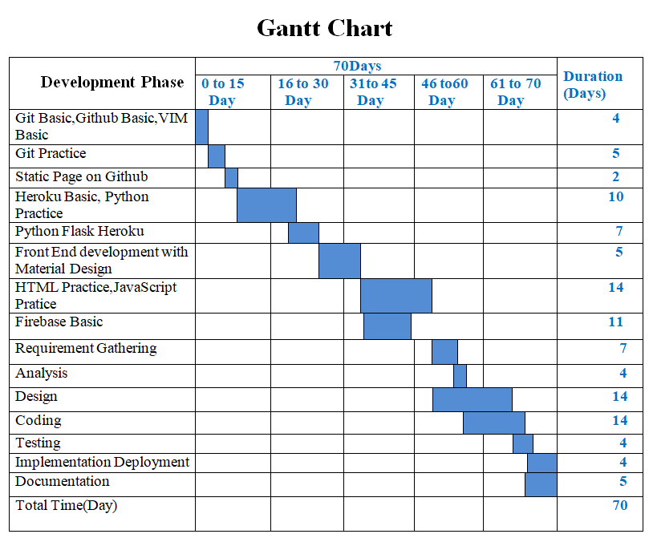

**Figure2.1 Project Plan**

7

**CHAPTER 3**

**PROJECT DEVELOPMENT**

**3.1 Design**

**3.1.1 Flow Chart Diagram**

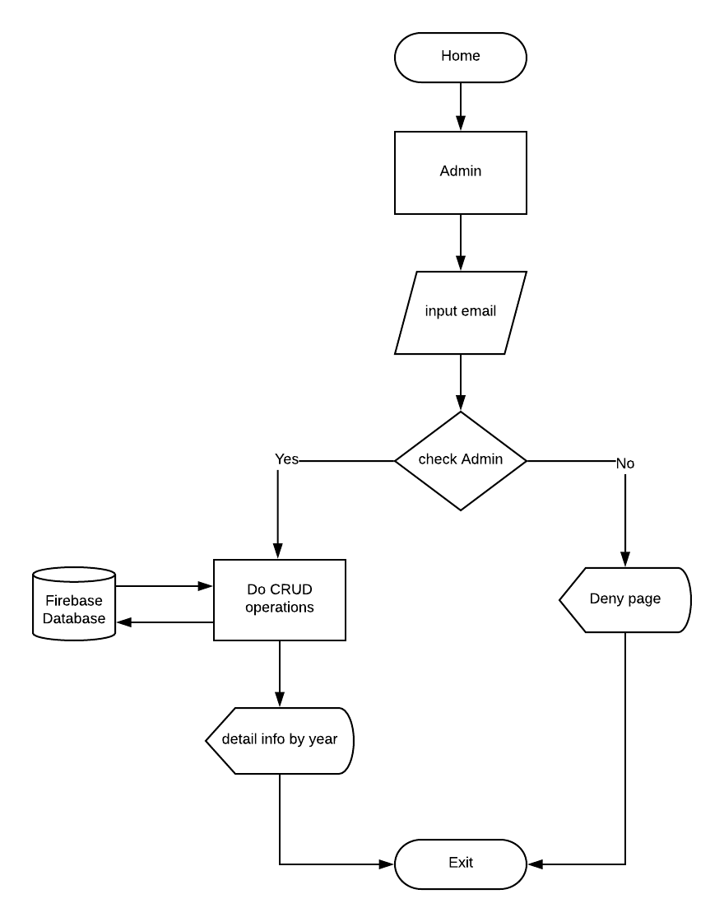

**Figure 3.1 Flowchart Diagram For Admin**

**8**

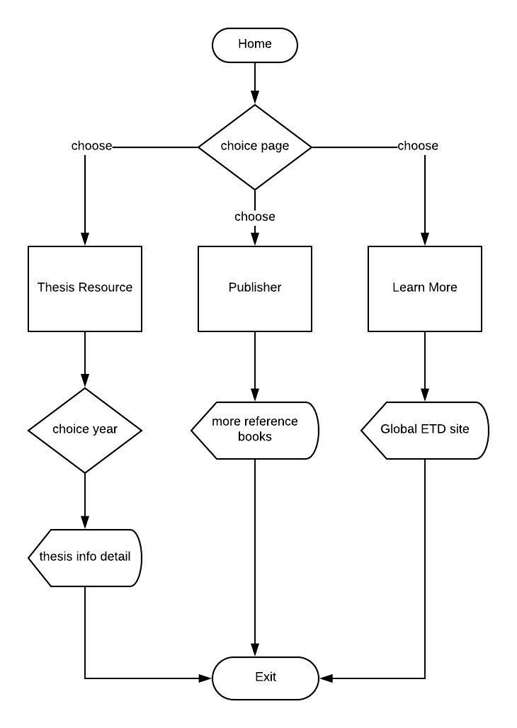

**Figure 3.2 Flowchart Diagram For User**

**9**

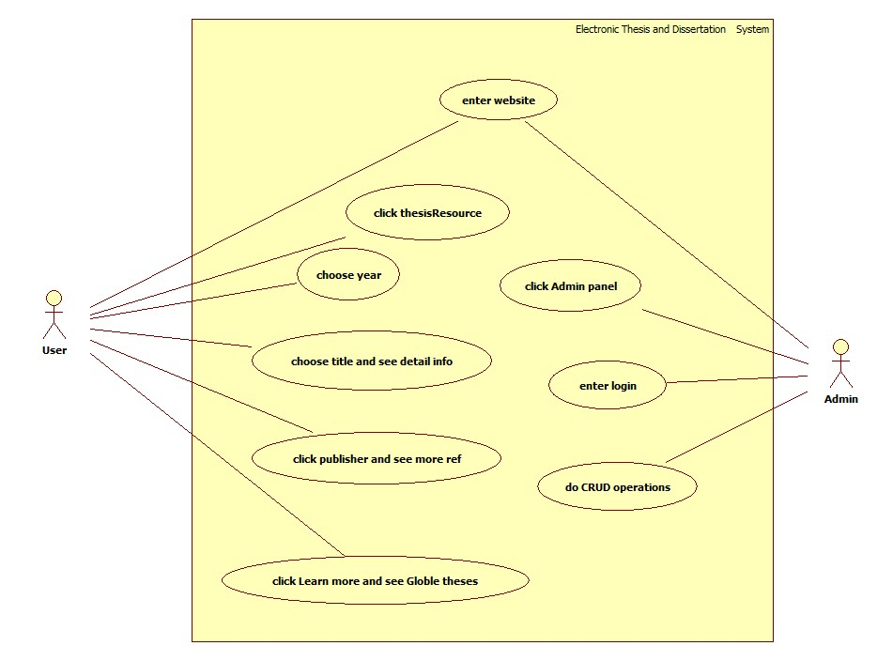

**Figure 3.3 UseCase Diagram For ETD**

**10**

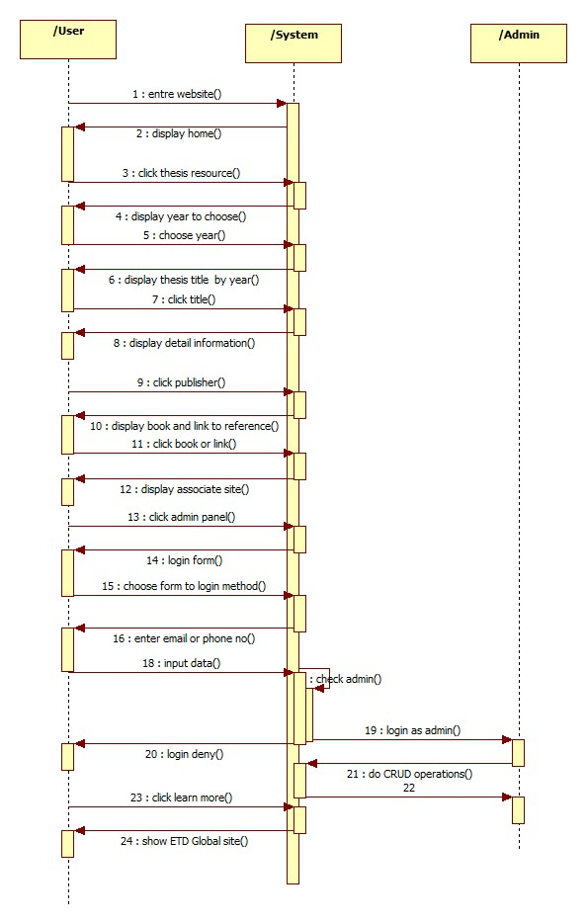

**Figure 3.4 Sequence Diagram For ETD**

**11**

**3.1.4 ETD Function**

In this system, we use navigation bar. When users click navigation bar, users can see Home, ThesisResource , Publisher, Admin and Learn More.

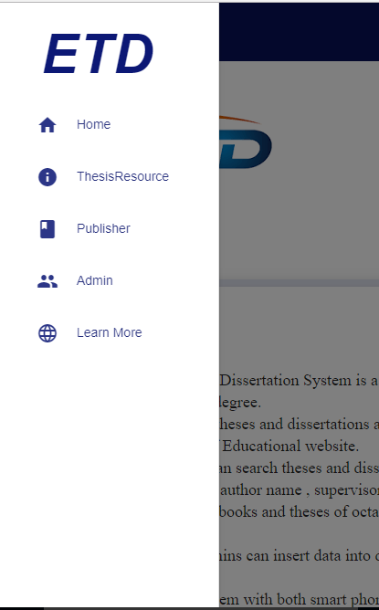

**Figure (3.5) Navigation Bar Form**

**12**

In Home Page form, we show Introduction, Type of Thesis, abstract, and objective.

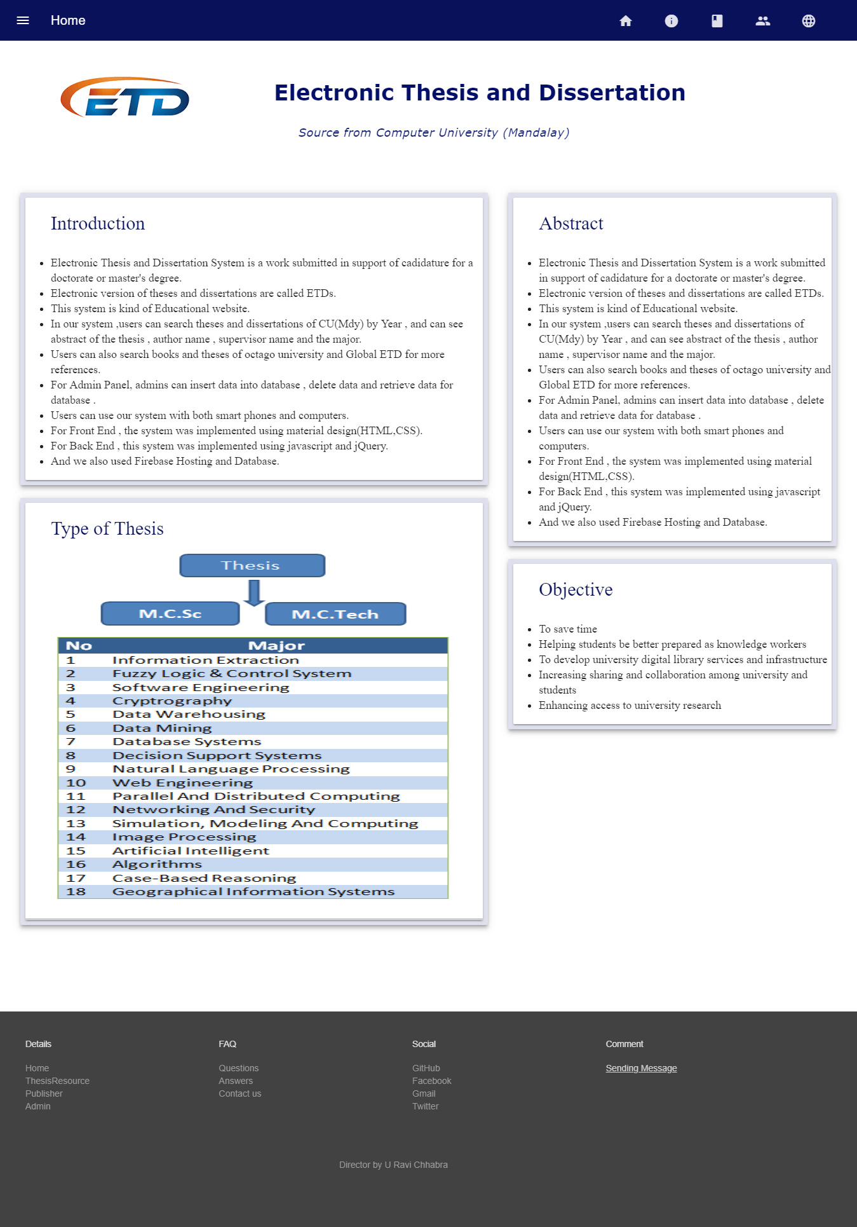

**Figure (3.6) Home Page Form**

**13**

In the following form,users can see thesis resource by year from 2008 to 2016.

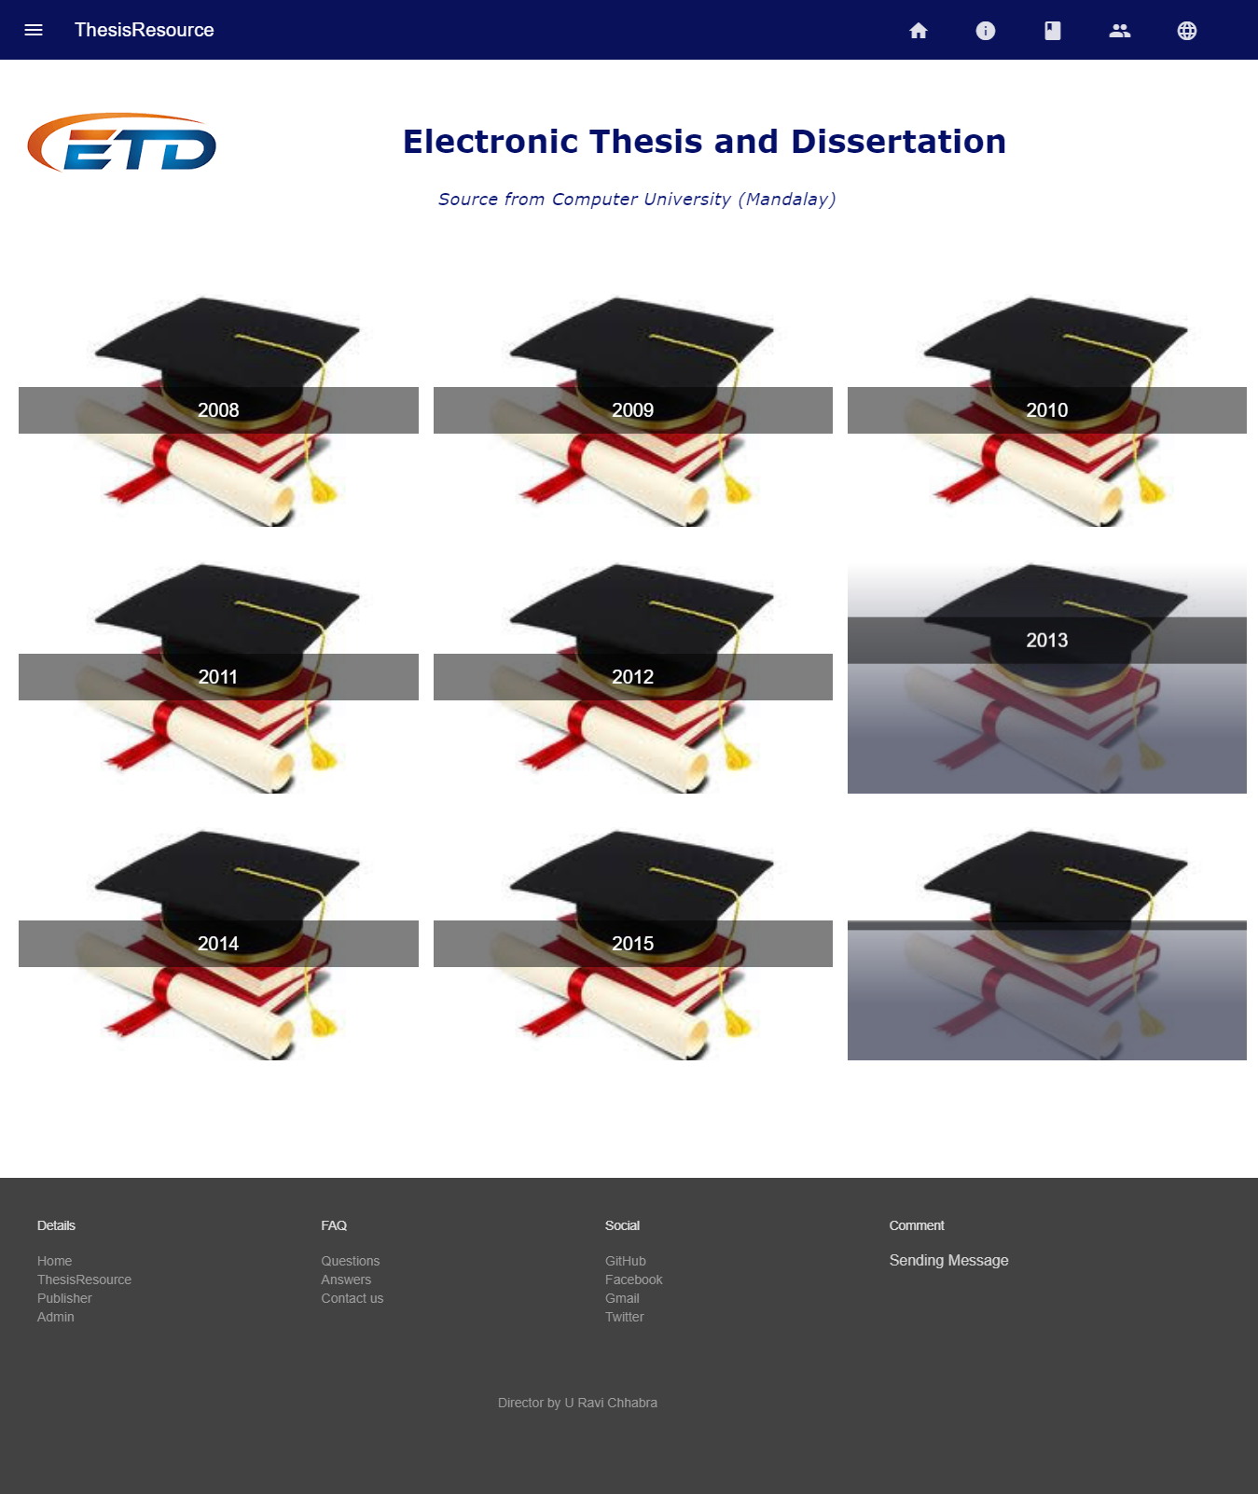

**Figure (3.7) Thesis Resource Form**

**14**

If user clicks 2008, user can see thesis titles in 2008.

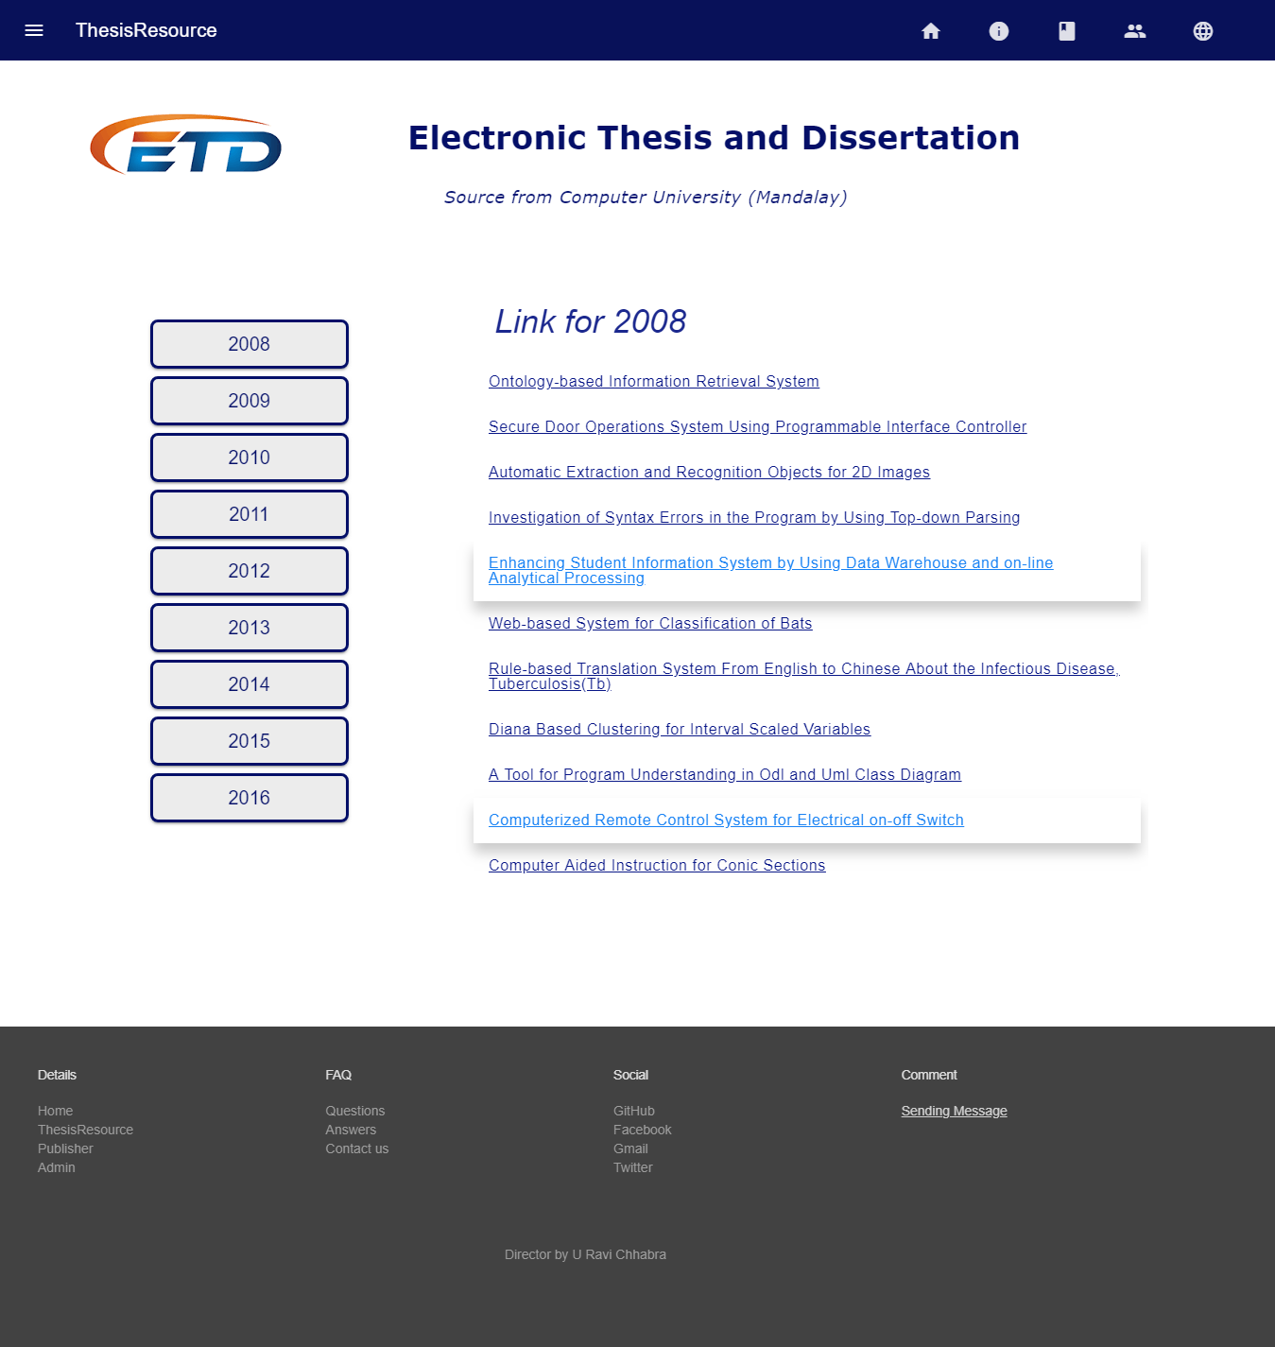

**Figure (3.8) Thesis Resource Form By Year And Title**

**15**

When user clicks thesis title, user can see the following form. There are Abstract of thesis, Author’s Name, Degree, Supervisor, Thesis Title, Major and Year.

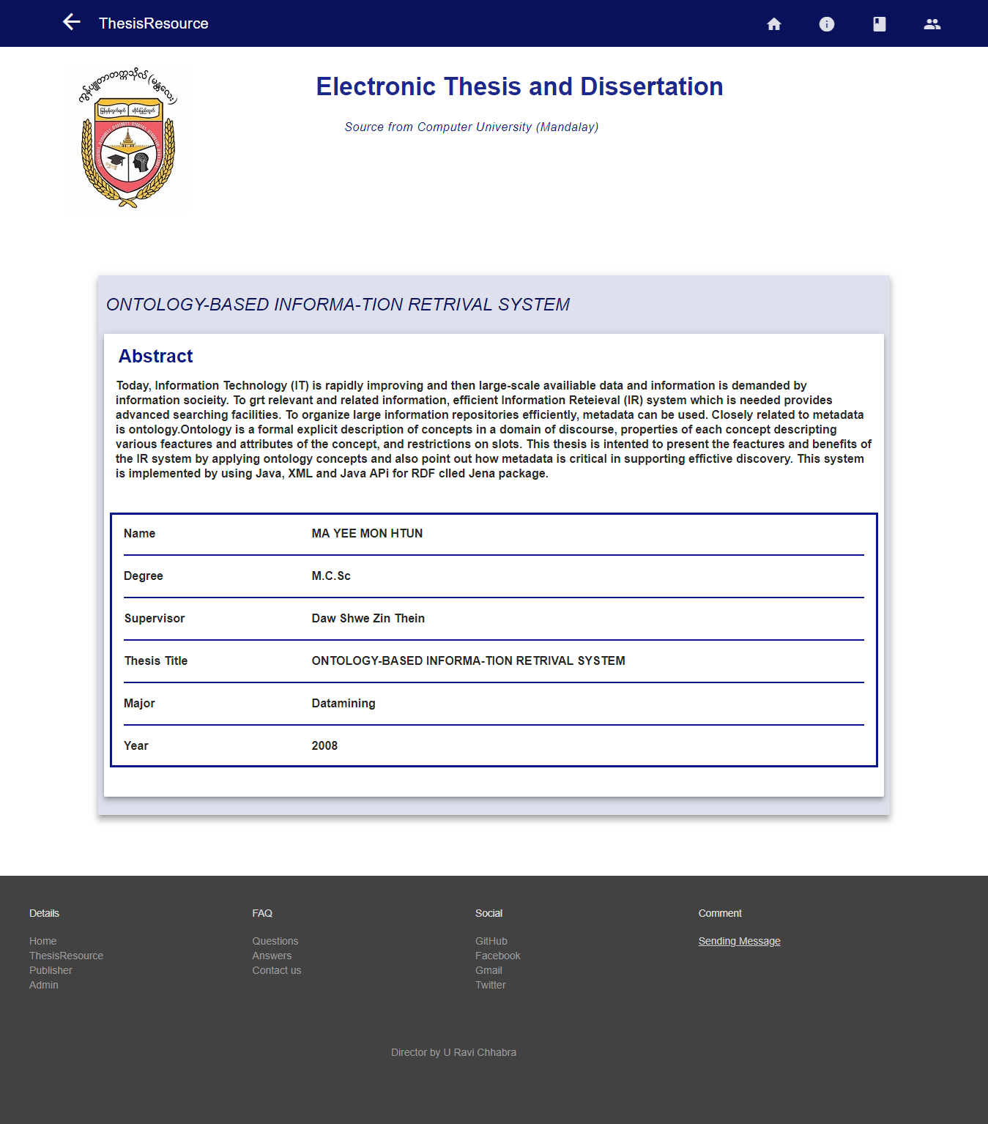

**Figure (3.9) Thesis Resource With Details**

**16**

User can see Books on doing research in Publisher.

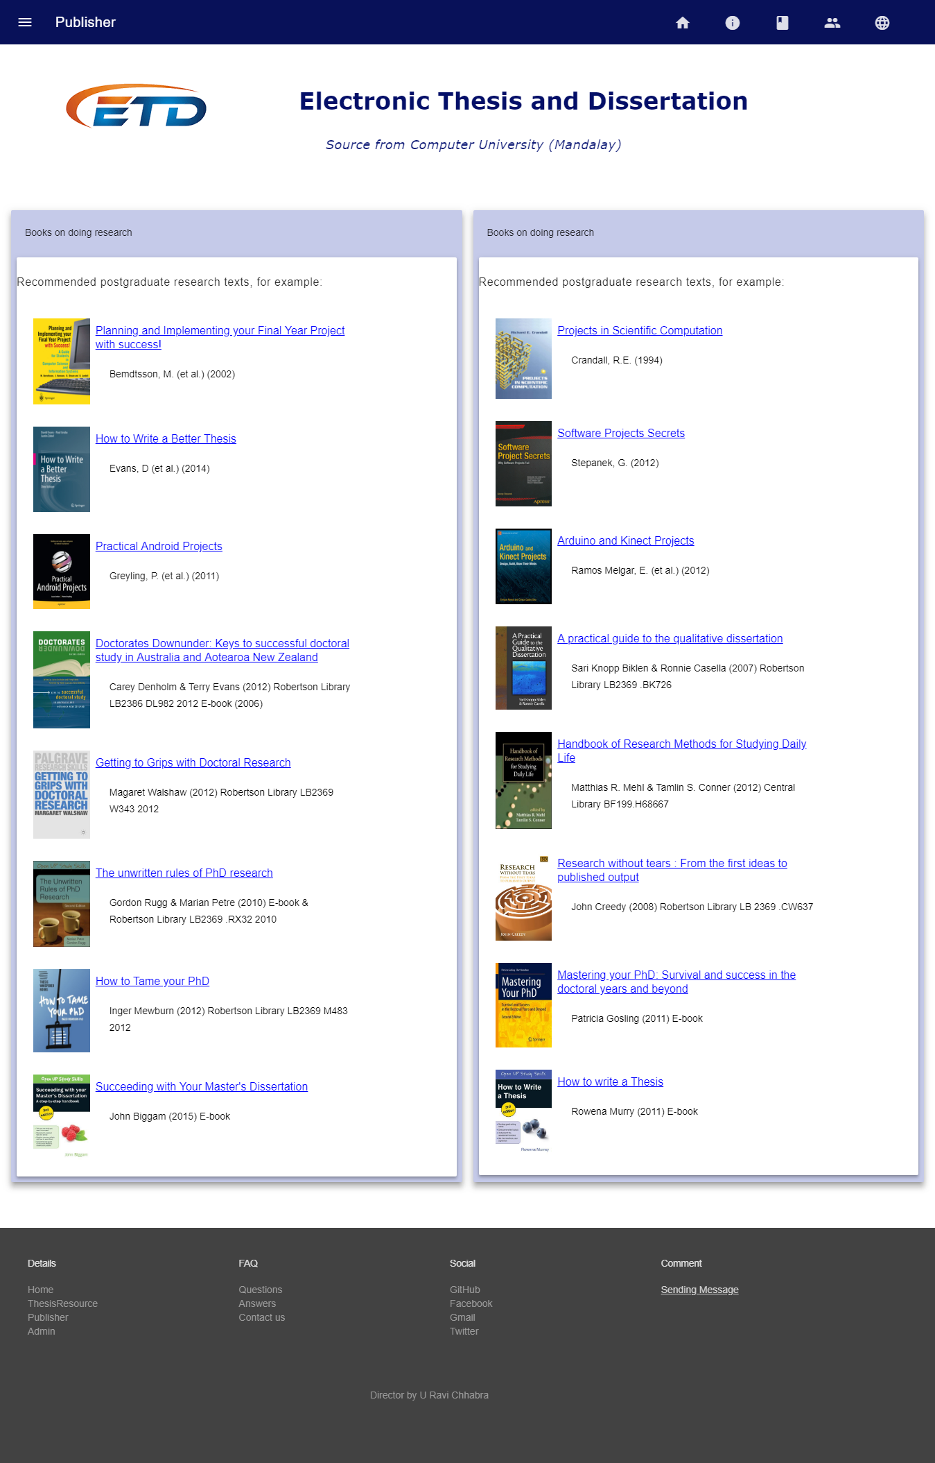

**Figure (3.10) Publisher Form**

**17**

When user clicks any title, user can see the information of the title that user click.

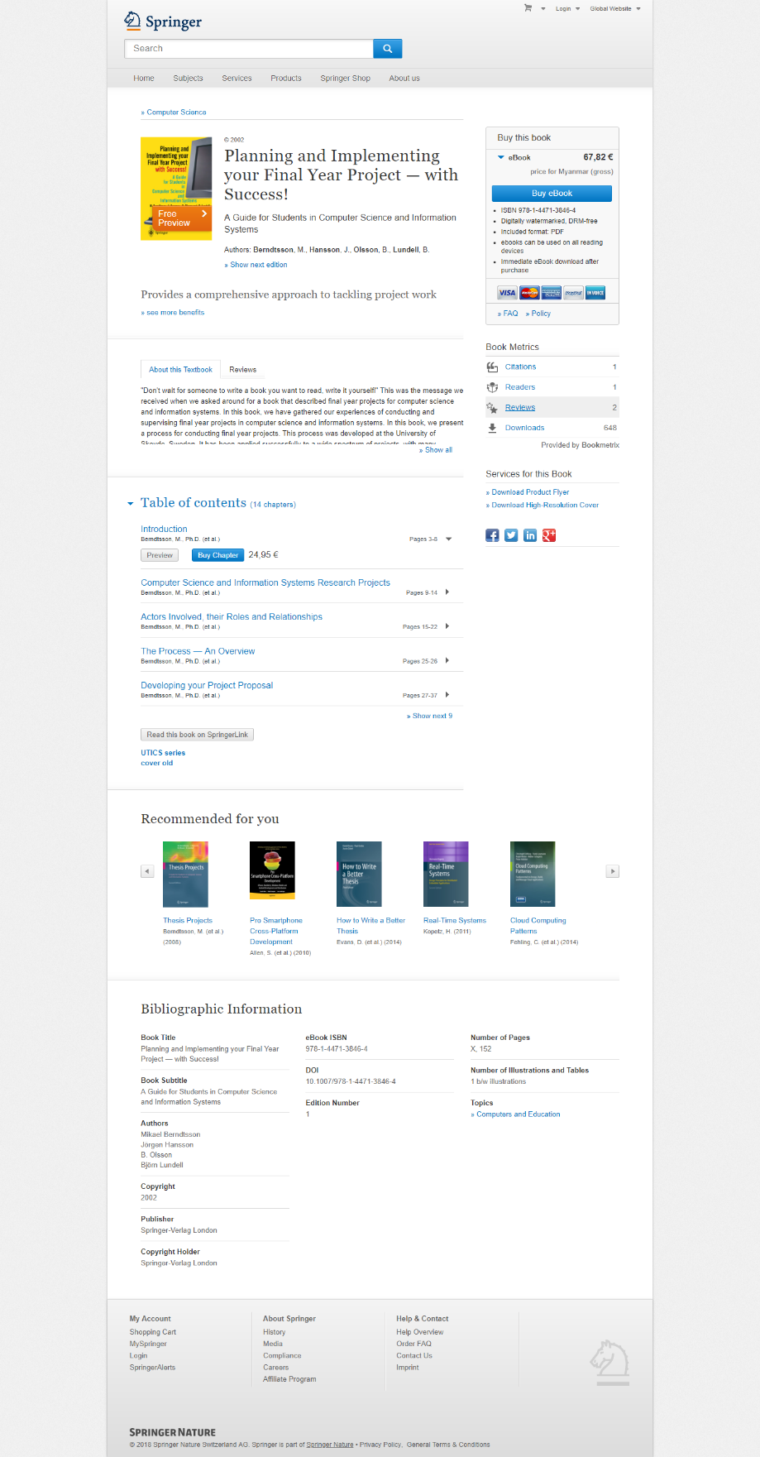

**Figure (3.11) Information Of The Title That User Click**

**18**

In the following form, admins can only login to create, delete, update and add data.

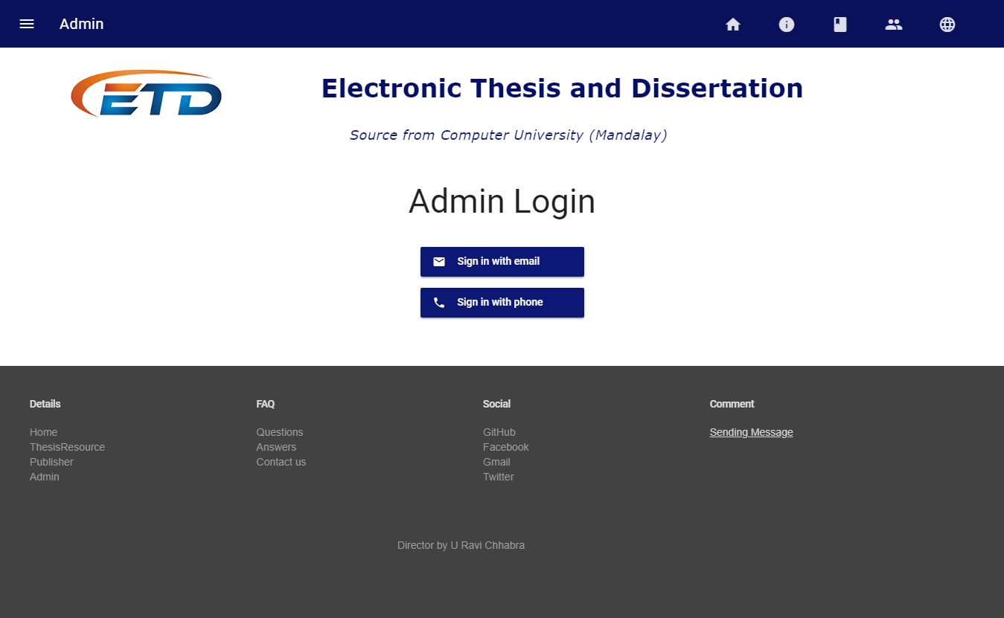

**Figure (3.12) Admin Form**

We design Admin login form to login not only email but also phone number. Admin need to create an account to login.

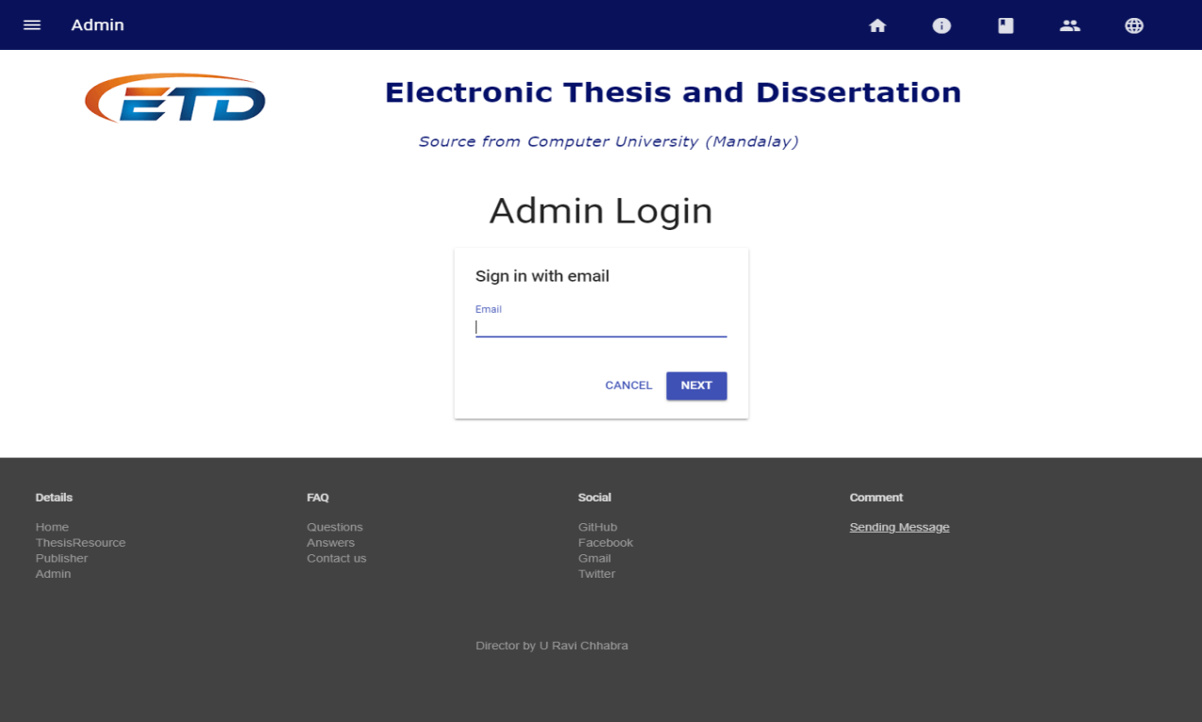

**Figure (3.13) Admin Login Form With Email**

**19**

After login, admins can create, update and delete data.

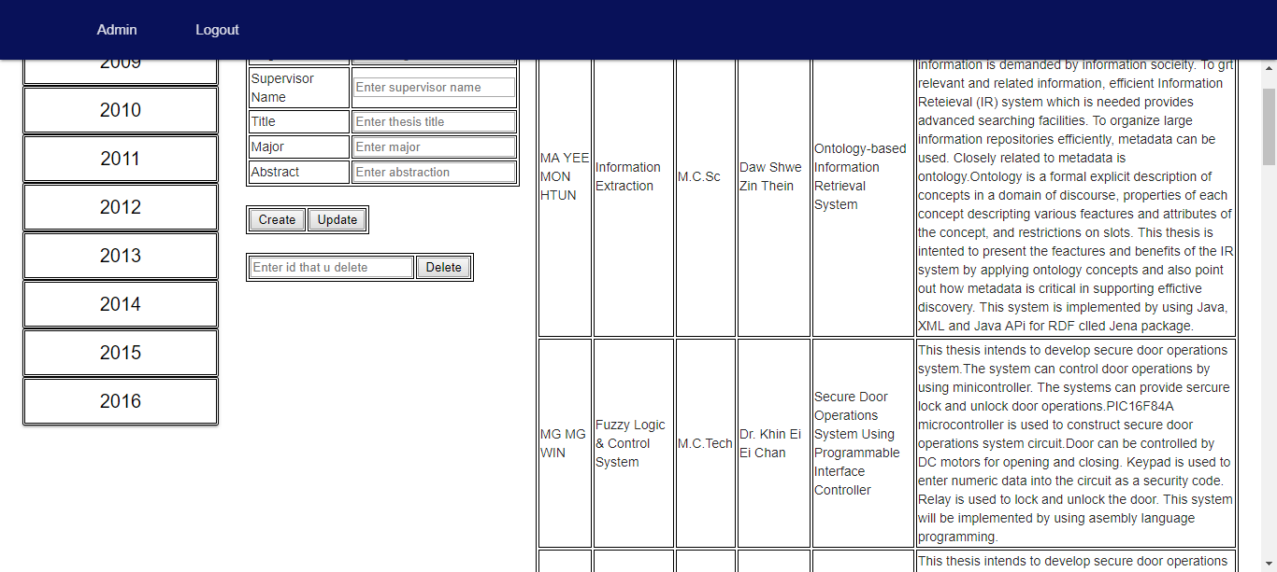

**Figure (3.14)Detail Information By Year For Admin**

In the below form, user can search Theses in global and it combines with 5,111,718 electronic theses and dissertations where can find any fields that you want .

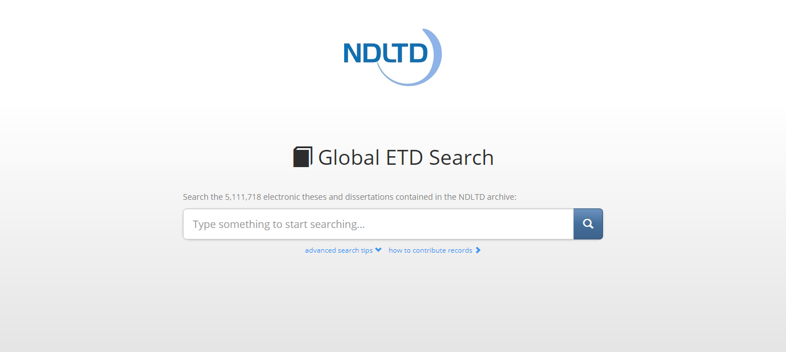

**Figure (3.15) Learn More Form**

**20**

In Global ETD Search, user can see like this.

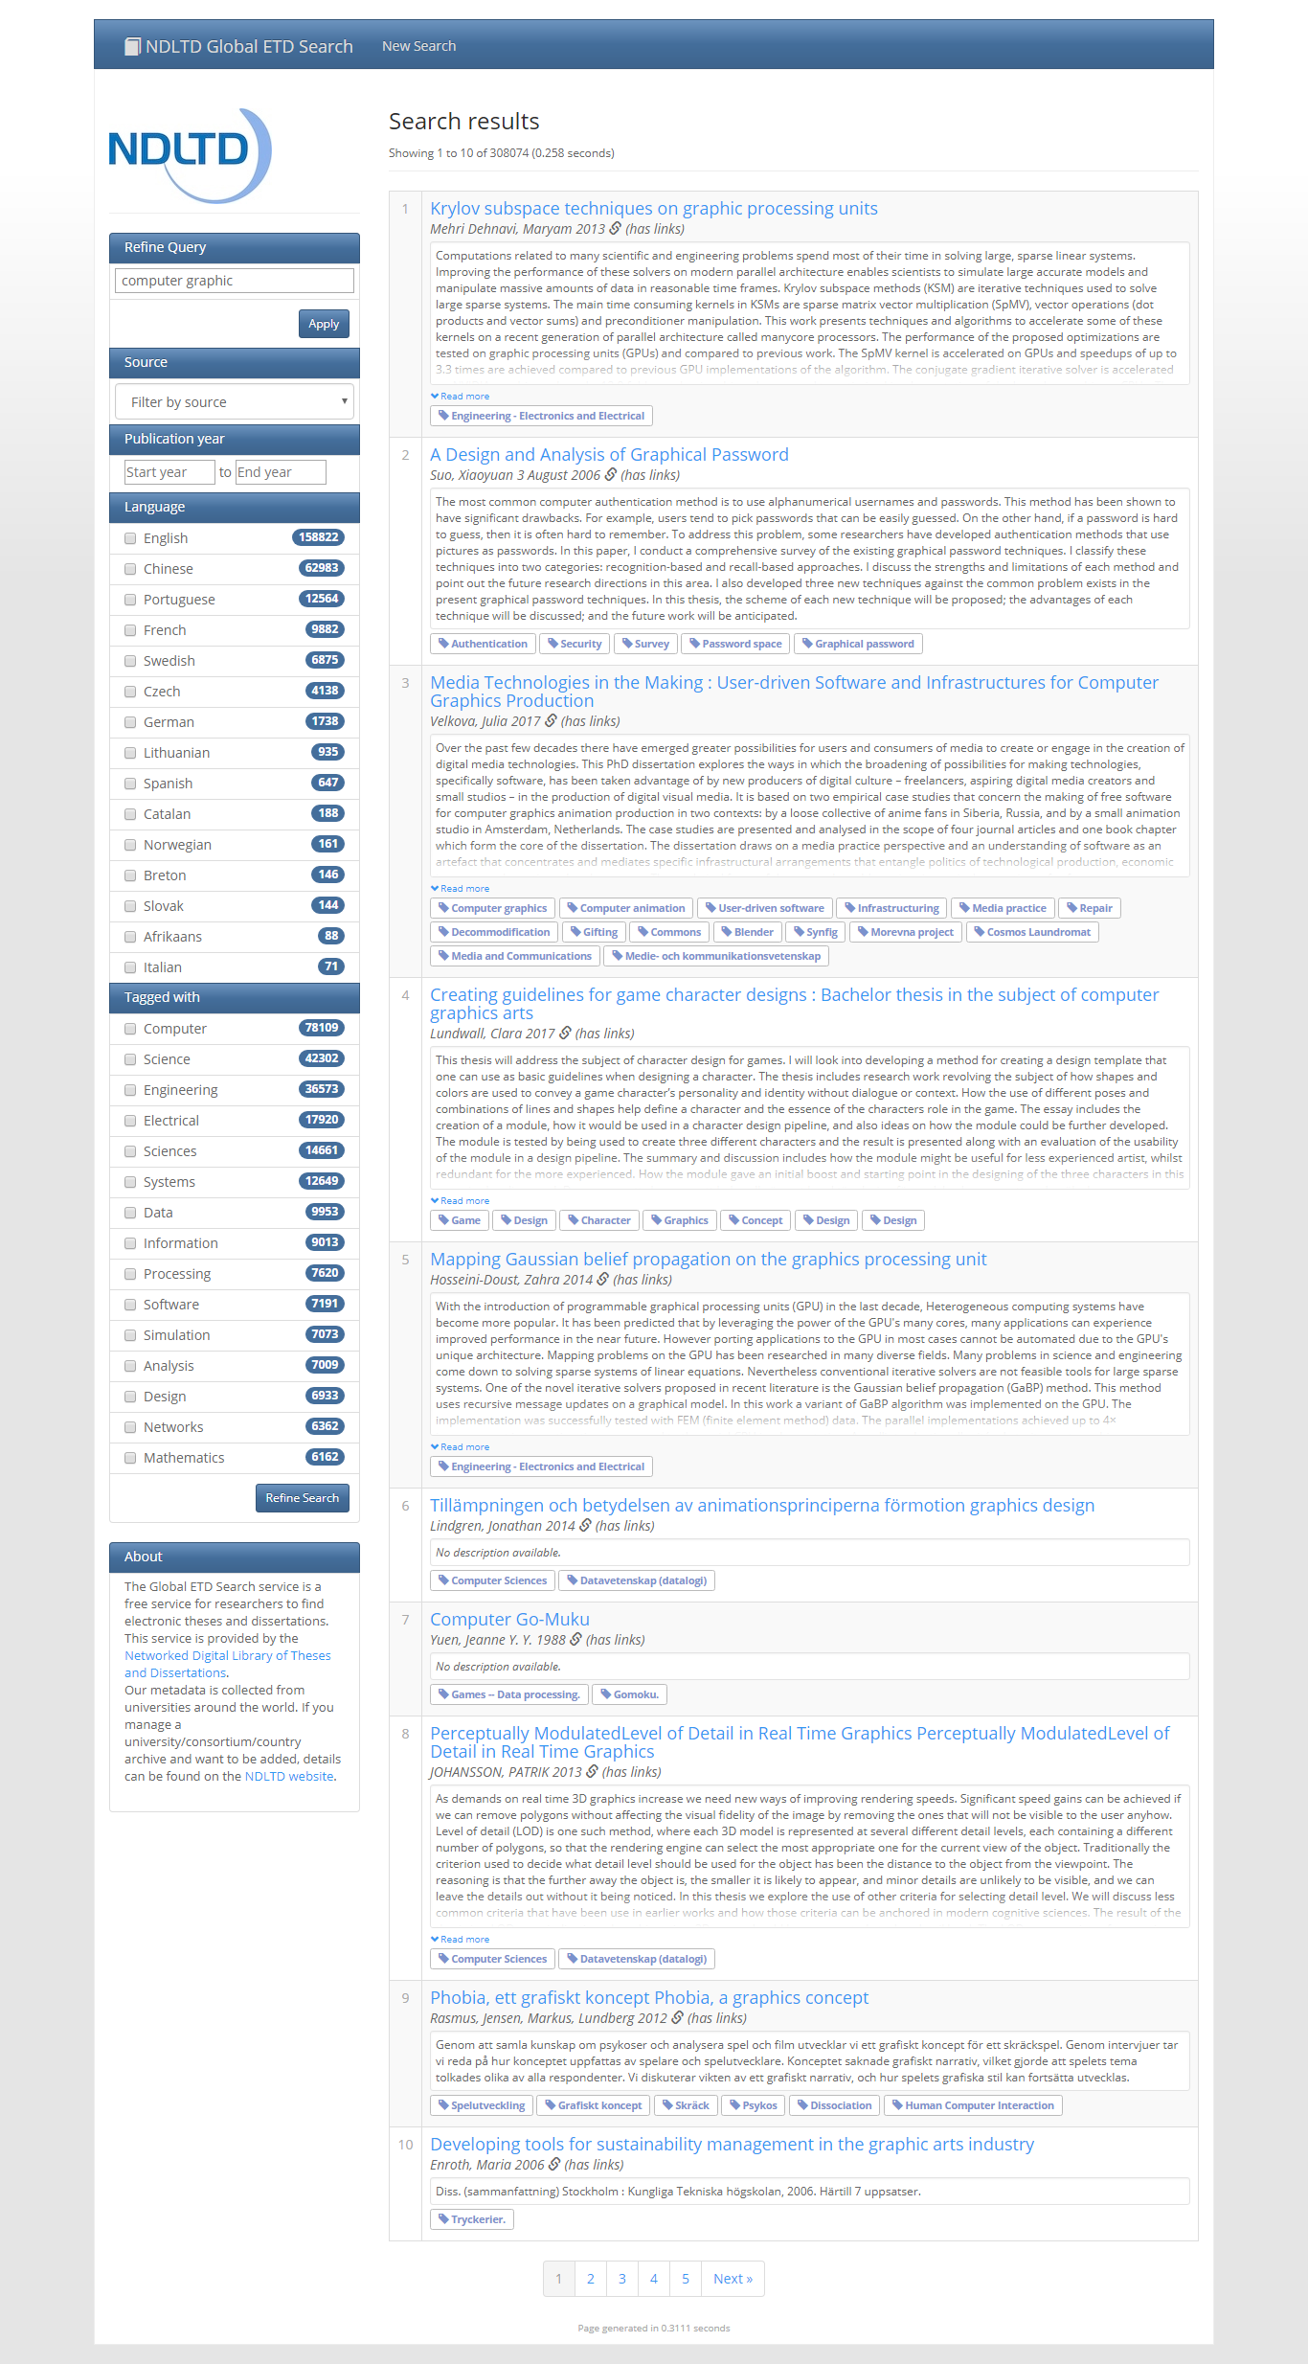

**Figure (3.16) Global ETD Form**

**21**

**3.2 Implementation**

When you user our system, you need to have one browser with internet access on smart phone or computer.

**3.2.1 Database Implementation**

**Firebase RealTime Database**

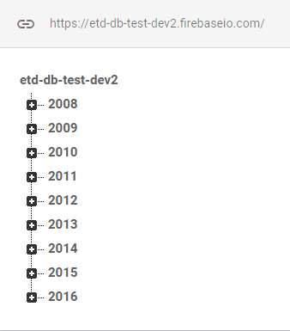

**Figure (3.17) Data Of Project**

**22**

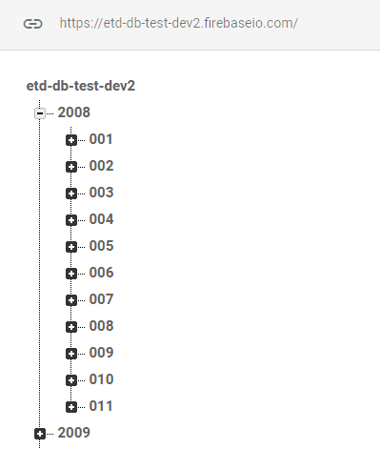

**Figure (3.18) Data Of Each Year Under Project**

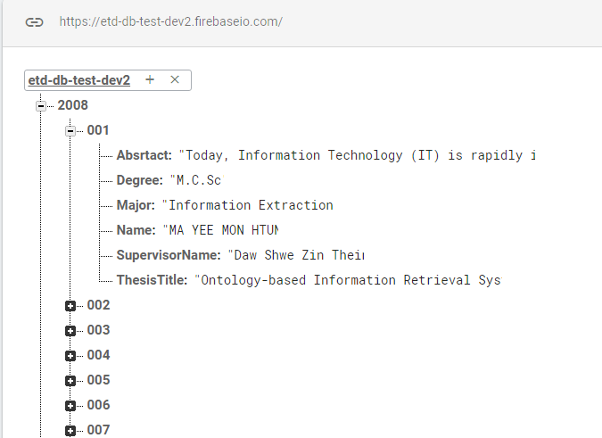

**Figure (3.19)Data Of Each Id Under Year**

**23**

**3.3 Testing**

This is our project milestone. According to this, we take 10 days for testing to ensure safety system.

**Figure (3.20)**

**24**

**Table (3.1) Integration Testing**

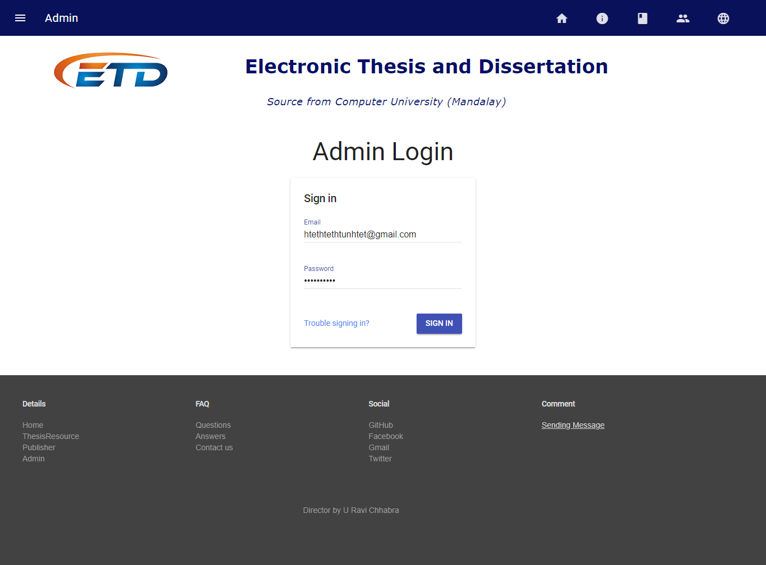

**Figure (3.21) Allow Login And Check Permission**

**25**

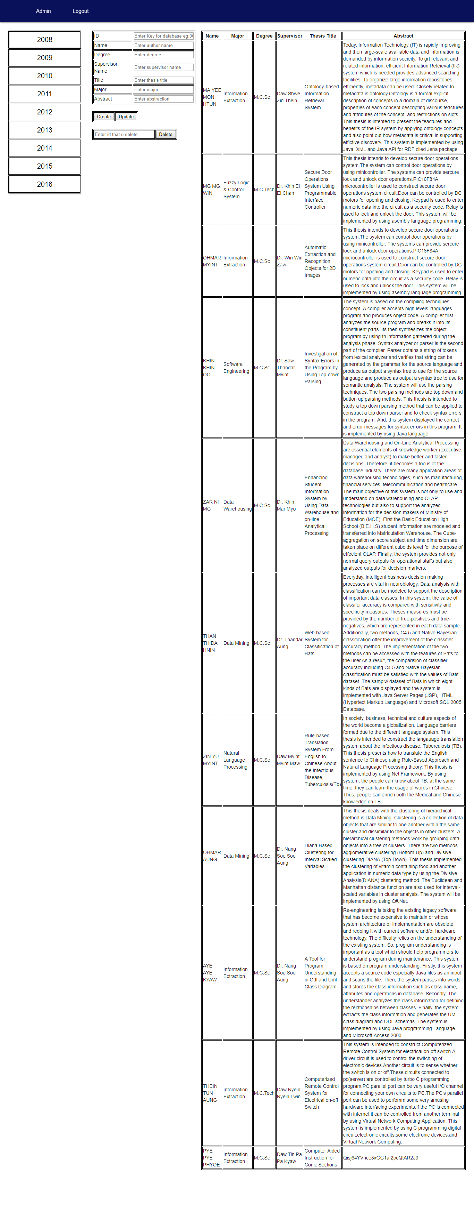

**Figure (3.22) Permit Authorization Person**

**26**

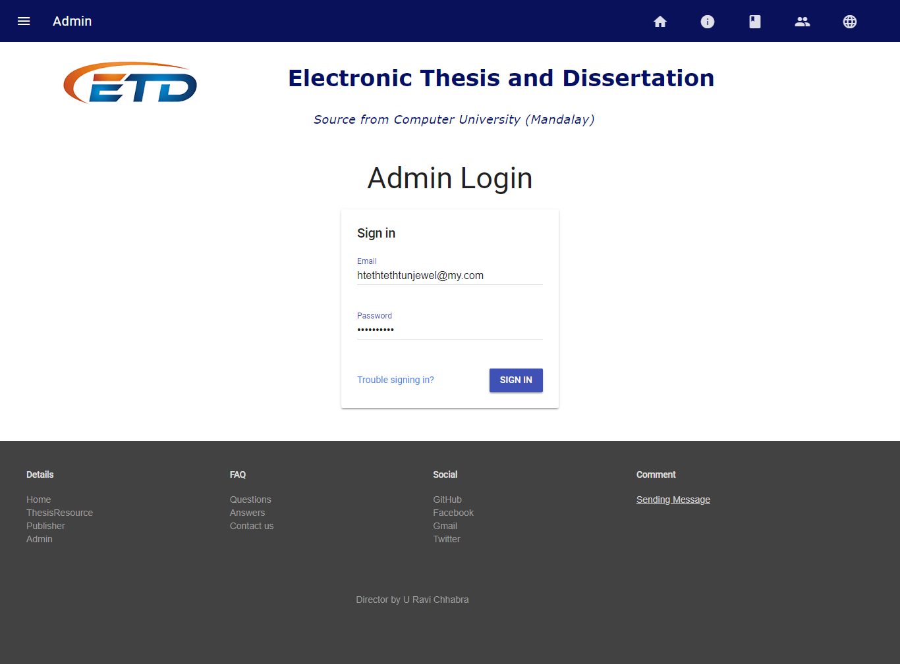

**Figure (3.23) Allow Login And Check Permission**

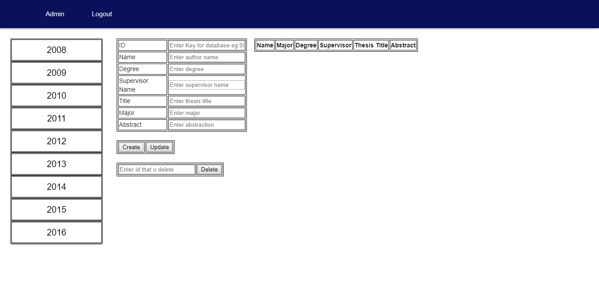**Figure (3.24) Permission Deny When Not Given Authorization**

**27**

**CHAPTER 4**

**EVALUATION AND CONCLUSION**

**4.1 Conclusion**

**28**

**4.2** **Advantages of the Project**

The proposed system offers the following advantages:

* It provides “faster and better” services to users.
* This is helpful in assessing what’s in progress, what has written, the writing style, how it was structured, research methods, and which reference were used.
* User can satisfy because they can search not only thesis title but also by year.
* Assisting postgraduate students to write.
* Provide facility for proper monitoring, reduces paper work and provide data security.

**4.3** **Disadvantages**

* The cost of computer hardware and software programs can be expensive.
* As mobile tablets use wireless network, they can disconnect with network if Wi Fi fails

**4.4 Further Extensions**

This application has incompleteness from various view-points. Because our university doesn’t have hard copy. So, we give you abstract of thesis of our university. Various functionalities can be embedded within the project.

**29**

**Reference**

* https://www.codecademy.com/learn/learn-the-command-line
* https://www.codecademy.com/learn/learn-git
* https://github.com/
* https://github.com/mayeedwin/profile
* https://vim-adventures.com/
* https://try.github.io/levels/1/challenges/1
* <https://my.wikipedia.org>/
* https://about.gitlab.com/
* http://ask.tiide.org/
* https://firebase.google.com/
* <http://ask.tiide.org/>
* https://materializecss.com/
* https://gitlab.com/
* http://learn.freecodecamp.org/
* http://search.ndltd.org/
* https://otago.libguides.com/thesisinformation
* https://firebase.google.com/docs
* https://getmdl.io
* https://www.csvjson.com/
* https://www.onlineocr.net/
* https://www.w3schools.com/

**30**